**Gandhi Jayanthi**

**2-10-2023**

Gandhi Jayanti is a national holiday in India, celebrated annually on October 2nd to honor the birth of Mohandas Karamchand Gandhi, popularly known as Mahatma Gandhi. Born on October 2, 1869, in Porbandar, Gujarat, Gandhi played a key role in India's struggle for independence from British colonial rule through nonviolent civil disobedience and peaceful protests.

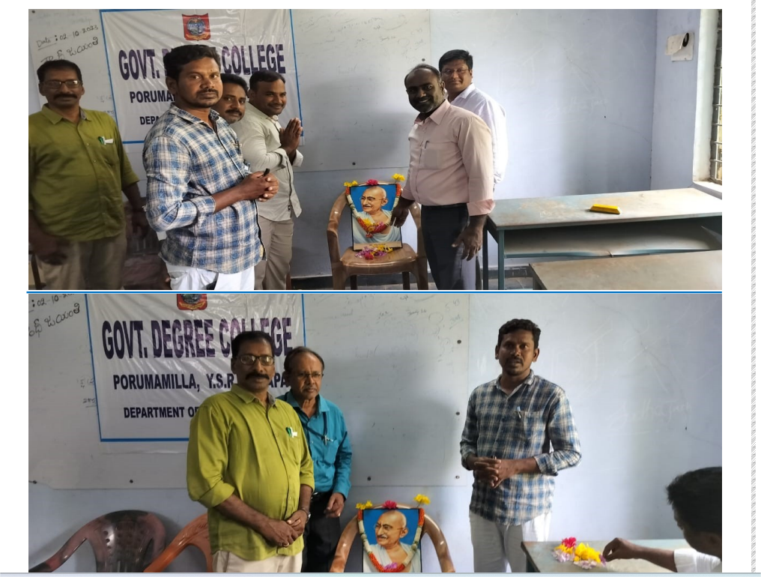

**Awareness programme On AIDS**

**12-12-2022**

An **Awareness Programme on AIDS** is a crucial initiative aimed at educating the public about **Acquired Immunodeficiency Syndrome (AIDS)**, which is caused by the **Human Immunodeficiency Virus (HIV)**. These programs are designed to provide knowledge about the transmission, prevention, and treatment of HIV/AIDS, as well as to reduce stigma and discrimination surrounding people living with HIV.

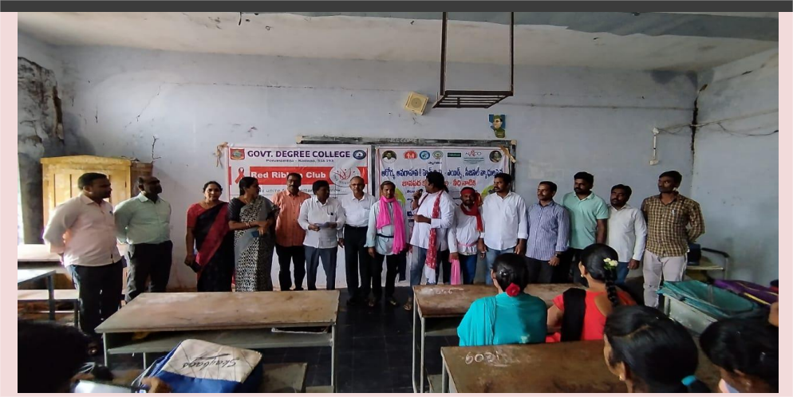

**74th Rebulic day celebrations**

**26-01-2023**

The **74th Republic Day** of India, celebrated on **January 26, 2023**, marked a significant occasion in the country’s history. Republic Day is observed every year to commemorate the adoption of the **Constitution of India** on January 26, 1950, which turned India into a republic. This day also honors the nation's freedom struggle and reflects India's democratic values and rich cultural heritage.

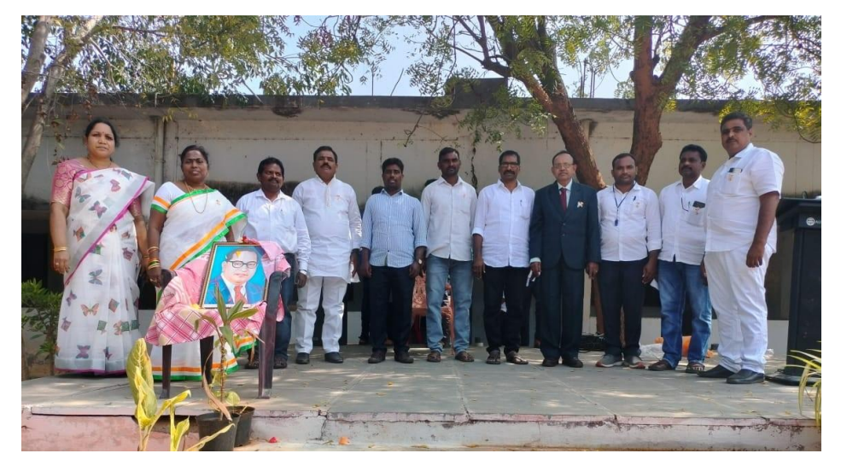

**Gandi death anniversary**

**30-01-2023**

**Gandhi's Death Anniversary**, also known as **Martyrs' Day**, is observed every year on **January 30th** in India to commemorate the assassination of **Mahatma Gandhi** in 1948. On this day, people across the country remember the life and sacrifices of Gandhi, who was a pivotal leader in India's struggle for independence from British rule and a global symbol of nonviolence and peace.

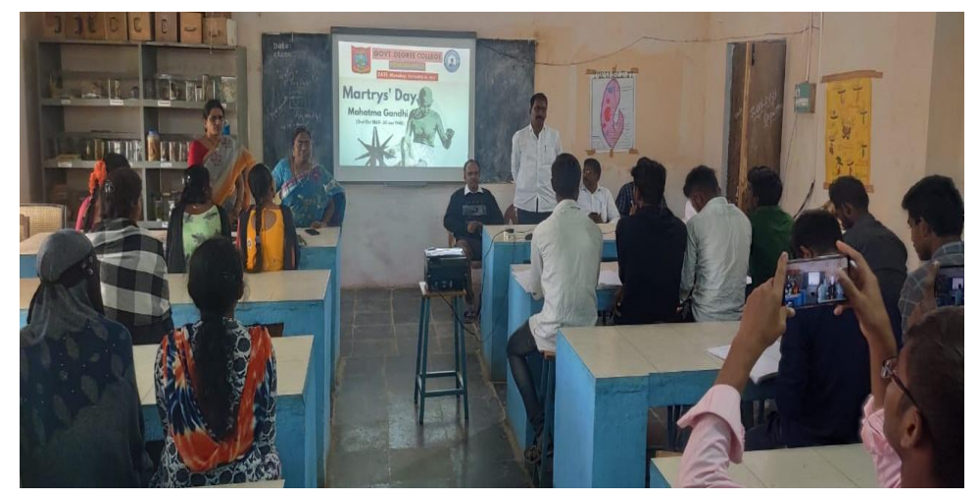

**Ambhedkar Death Anniversary**

13-3-2023

**Ambedkar Death Anniversary**, also known as **Mahaparinirvan Diwas**, is observed every year on **December 6th** to commemorate the death of **Dr. B.R. Ambedkar**, one of India's most influential leaders, social reformers, and the principal architect of the **Constitution of India**. He passed away on this day in **1956**.

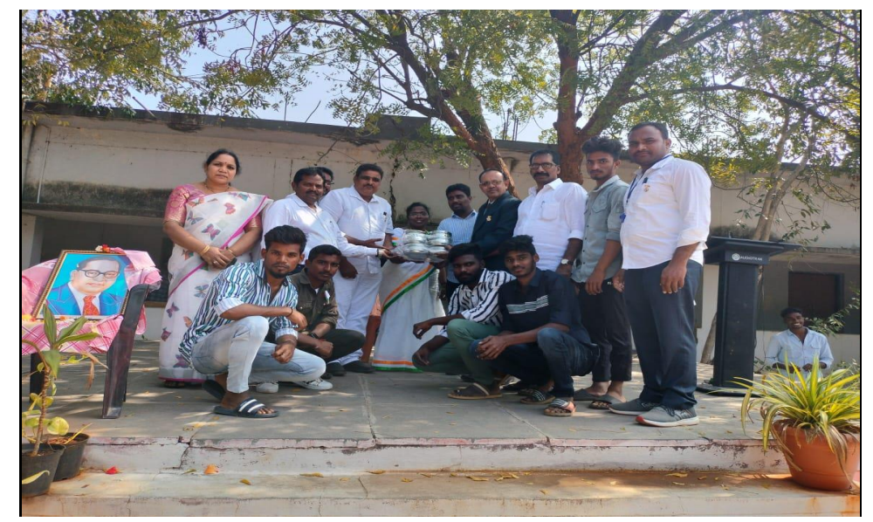

**Kandukuri veereshalingam Jayanthi**

16-4-2023

**Kandukuri Veeresalingam Jayanthi** is celebrated on **April 16th** every year to honor the birth anniversary of **Kandukuri Veeresalingam**, one of the pioneering social reformers and writers in **19th-century Andhra Pradesh**. He is regarded as one of the first individuals who worked towards the upliftment of society by advocating for social reforms, women's rights, and the spread of education in the region.

**Alluri seetha rama raju jayanthi**

7/4/2023

**Alluri Sitarama Raju Jayanti** is celebrated on **July 4th** every year to honor the birth of **Alluri Sitarama Raju**, a prominent Indian freedom fighter who led the **Rampa Rebellion** (also known as the **Alluri Rebellion**) against the British colonial rule in the early 20th century. He is often referred to as the **"Manyam Veerudu"** (the **Hero of the Forests**) for his efforts to lead the tribal people in the **hilly areas of Andhra Pradesh** to fight against the British.

**Plantation**

**8/11/2023**

**Plantation** refers to the process of planting and maintaining large-scale crops or trees, typically in an organized and managed manner. These can range from agricultural crops like **tea**, **coffee**, **rubber**, or **spices**, to **forestation** efforts aimed at improving the environment. Plantations have both **economic** and **environmental** significance, depending on the purpose of the plantation.

**Azadi ka Amruth Mahotshav**

8/12/2023

spans over a period of 75 weeks and includes various cultural, educational, and community activities aimed at recognizing the country’s history, achievements, and the struggles of those who fought for freedom.

The name "Azadi Ka Amrit Mahotsav" translates to “Festival of the Elixir of Independence” in English, symbolizing the spirit of freedom and the upcoming milestone of India's 75th year of independence, which was achieved in 1947.

**Meri Matti- Meri Desh**

8/14/2023

"Meri Matti, Meri Desh" translates to "My Soil, My Country" in English. It's a phrase that evokes deep feelings of patriotism, pride, and connection to one's homeland. This sentiment is often used in songs, poems, and speeches to express love for the land and the culture it represents.

Is this from a specific song or piece of writing that you're thinking about? It could also be a theme that resonates with you in some way.

**Tanguturi Prakasham Panthulu Jayanthi**

8/23/2023

Tanguturi Prakasam Pantulu, also known as **"Andhra Kesari"**, was a prominent freedom fighter, lawyer, and the first Premier of the Indian state of Andhra Pradesh. He was born on **February 23, 1872**. His birthday is celebrated as his **Jayanthi** (birthday celebration) in honor of his contributions to the freedom struggle and his role in the development of Andhra Pradesh.

Prakasam Pantulu is especially remembered for his passionate involvement in the Indian independence movement. He earned the title "Andhra Kesari" (Lion of Andhra) due to his fearless and unwavering dedication to the cause of freedom. He played a significant role in the Non-Cooperation Movement, and later, during the Salt Satyagraha, he famously led protests in the coastal regions of Andhra Pradesh.

He was known for his fiery speeches, legal expertise, and a deep sense of patriotism. His leadership extended beyond the political realm, and he also worked towards the upliftment of the people of Andhra. He was the Prime Minister (now known as the Chief Minister) of Andhra State from 1953 to 1956.

Would you like to know more about his life or specific events associated with his Jayanthi?

**Blood Donation**

8/29/2023

Blood donation is the voluntary process of giving blood to be used in medical treatments or emergencies. Donated blood can help save lives in various situations, such as surgeries, accidents, cancer treatments, and for patients with conditions like anemia or hemophilia. Here’s a breakdown of the key aspects of blood donation

**RJD Visit & Plantation**

9/25/2023

It sounds like you might be referring to a visit or event involving the **(RJD)**, which is a possibly combined with a **plantation drive** or initiative. College Staff and Students often organize such events as part of their community outreach, environmental awareness, or social welfare efforts. Here's how these two elements might be connected

**Gandhi Jayanthi**

**10/2/2023**

**Gandhi Jayanti** is a national holiday in India that celebrates the birth of **Mahatma Gandhi**, one of the most influential leaders in the country's history. It is observed on **October 2nd** each year, marking the birth of Gandhi in 1869. Gandhi is widely known for leading India to independence through non-violent civil disobedience and for his philosophy of **Ahimsa (non-violence)** and **Satyagraha (truth-force)**.

**Campus Cleaning**

**10/3/2023**

**Campus cleaning** refers to the organized effort to clean and maintain the cleanliness of college campus. It is an important activity to create a healthy and pleasant environment for students, faculty, staff, and visitors. Campus cleaning can be a part of regular maintenance routines or special events.

**World Teachers Day**

**10/5/2023**

**World Teachers' Day** is celebrated on **October 5th** each year to recognize the critical role teachers play in shaping the future of individuals and societies. It is an opportunity to honor educators for their hard work, dedication, and impact on the lives of students across the globe.

**National Unity day**

**10/31/2023**

National Unity Day, also known as **Rashtriya Ekta Diwas**, is observed in India on **October 31** each year. The day celebrates the birth anniversary of **Sardar Vallabhbhai Patel**, one of India's foremost leaders and the first Deputy Prime Minister and Home Minister of India. He played a key role in the integration of princely states into the Indian Union after independence and is often referred to as the "Iron Man of India" for his efforts in maintaining national unity.

The day was officially declared in 2014 to honor Patel’s contributions to the unity and integrity of India. It serves as a reminder of the importance of national integration and promotes the spirit of unity among the people of India. On National Unity Day, various events are organized across the country, including **Run for Unity**, rallies, and discussions to emphasize the significance of unity in diversity.

Additionally, a prominent feature of the day is the **Statue of Unity**, the world's tallest statue, dedicated to Sardar Patel, which stands at a height of 182 meters in the state of Gujarat. It is a symbol of India's commitment to preserving unity and integrity.